

Student Names: Charlie Coad (20102084)
Module: Artificial Intelligence and Machine Learning
CA No.: 1
Lecturer: Abdul Shahid
Submission Date: 13/04/2026
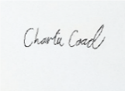
Signed: _______ Date: 13/04/2026

Table of Contents
Introduction 3
Overview of Dataset: 3
Exploratory Data Analysis (EDA) Findings 4
Outlier Detection 4
Descriptive Statistics: 8
Visualisations and Pattern Revealing: 9
Correlation Heatmap 9
Count Graph: Returning customers vs none returning 10
Count graph: Devices vs returning Customers 11
Pie chart: Gender Distribution: 12
Histogram: Age Distribution: 13
Histogram: Review Rating Distribution 14
Bivariate Analysis: Returning Customer by Product Category: 15
Boxplot: Returning customers vs Webpage Session Duration 16
Machine Learning Model Justification and Implementation 17
Decision Tree and Random Forest 17
Gradient Boosting 18
Gradient Boosting model – utilising the Grid Search Technique 19
Logistical Regression 21
Artificial Neural Network 23
First Models Results – Price Features 26
Second Models Results – User Experience Features 28
Third Models Results – Price + User Experience Features 29
Conclusion 30
References 31

Report for creating the optimal Machine Learning Model on a Customer Behaviour Prediction Dataset.

Introduction
I have been hired by a Retail Business as a Business Data Analyst, where I have been tasked with creating a Machine Learning Model that can identify the likelihood that a customer will return to their online retail website or not based on the characteristics and behaviour of that customer. This is because this business wants to understand human behaviour and what will influence them to return to their business’s website, as customers are most likely to purchase from the website if they are returning frequently. By identifying these patterns, the business can better look at the trends that contribute to customers that are not returning and make business decisions to correct or fix them going forward.
I will be aiming to utilise and experiment with different Machine Learning models, techniques and algorithms to identify the optimal churn prediction model that will provide me with the least bias and the most accurate results. In addition to this, this analysis will also aim to examine the different groups of variables that are heavily influencing the models prediction in order to understand which variables are having the greatest impact on customer’s behaviour to return to the website.

Overview of Dataset:
I will be utilising an E-Commerce Customer Behaviour and Sales Analysis Dataset which I sourced from Kaggle. This dataset can be found here: https://www.kaggle.com/datasets/umuttuygurr/e-commerce-customer-behavior-and-sales-analysis-tr and was created by user “UmutUygurr”
This data set contains 17,049 rows of data, and 18 columns. The variables/columns consist of customer related data that is a mix of numerical columns such as Unit_Price, Quantity, Total_Amount, Pages_Viewed, Delivery_Time_Days and Customer_Rating. It also contains a lot of Categorical data such as in the columns: Age, Gender, City, Product_Category, Device_Type and most importantly Is_Returning_Customer.
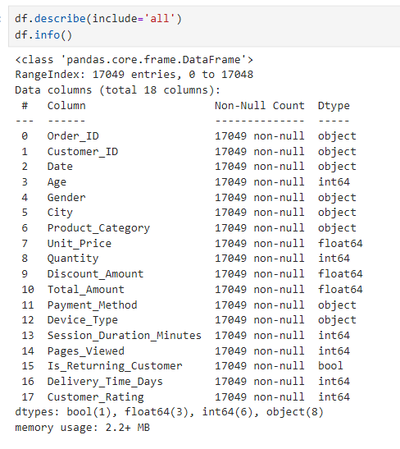
I will be utilising the column Is_Returning_Customer as my main Classifier because it clearly highlights which customers are returning customers and which are not. This is what the business wants to know which customers are returning and which are not and if these variables influence these customers to return or not.

Exploratory Data Analysis (EDA) Findings

Outlier Detection
First I conducted some simple Outlier Detection visuals using the boxplot mapping in Pandas. Below I looked at Age, Unit Price and Total Amount, to get a better idea of the average ages using the website, how much the prices of the products on the site cost and how much on average people are paying in total.
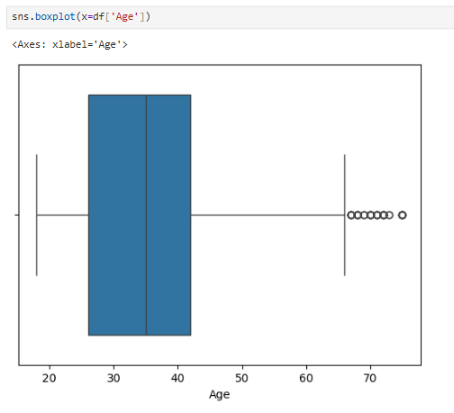
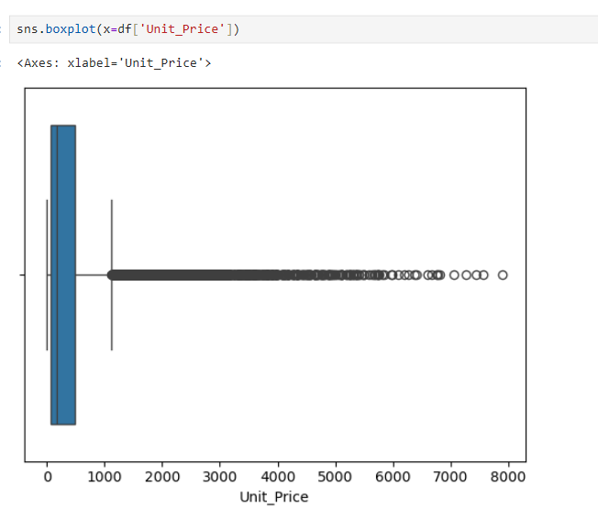

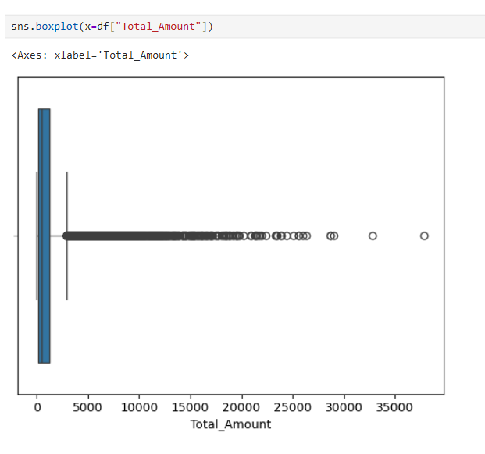
As I have mentioned in my screenshots above: My data does contain outliers and some of these box plots such as Unit_Price and Total Amount, are being squeezed into the left side for 2 main reasons:
- The size of the data: 17,049 rows
- A majority of the items having lower prices than the minority of items that have very high prices. However this is to be expected in a retail business as they may sell a variety of different products with ranging prices. Total_Amount also dosent take into account Quantity which also needs to be considered.
This creates its visually ambiguous look upon first glace. However this is very typical with retail stores as generally most items purchased would be substantially smaller in cost in regards to the products that are at premium prices.

Descriptive Statistics:
Here we can see the Mean, Standard Deviation, Min, Upper and Lower Quartiles and the Max of our Numerical columns.
Interesting insights from looking the numerical data: The average age is 35 which tells us that mostly young adults are shopping here, we can also see that most people are spending roughly 1277 dollars on their shopping and their review score is a 3.8 out of 5.
On the categorical data side we can see that this dataset mostly consists of Females, with a majority of the customers being from Instanbull and most customers purchasing items from the Sports section. Finally we can see that most of our customers are returning customers.

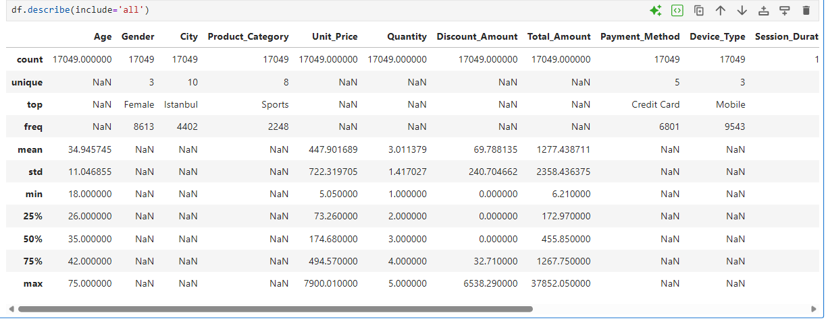

Visualisations and Pattern Revealing:

Correlation Heatmap
For my first visualisation I want to find the correlation between the Integer columns within my dataset. I did this by calling in the Seaborn library and using a correlation function to visualise the columns on a heatmap
This heat map is to be read as the Lighter colours represent a weak correlation and the darker colours represent a strong correlation.
Below we can see that the Unit Price, Quanity, Discount Amount and Total Amount all have a correlation between one another however the rest of the columns do not, which is to be expected. Below we can see that the Unit Price, Quantity, Discount Amount and Total Amount all have a correlation between one another however the rest of the columns do not, which is to be expected:
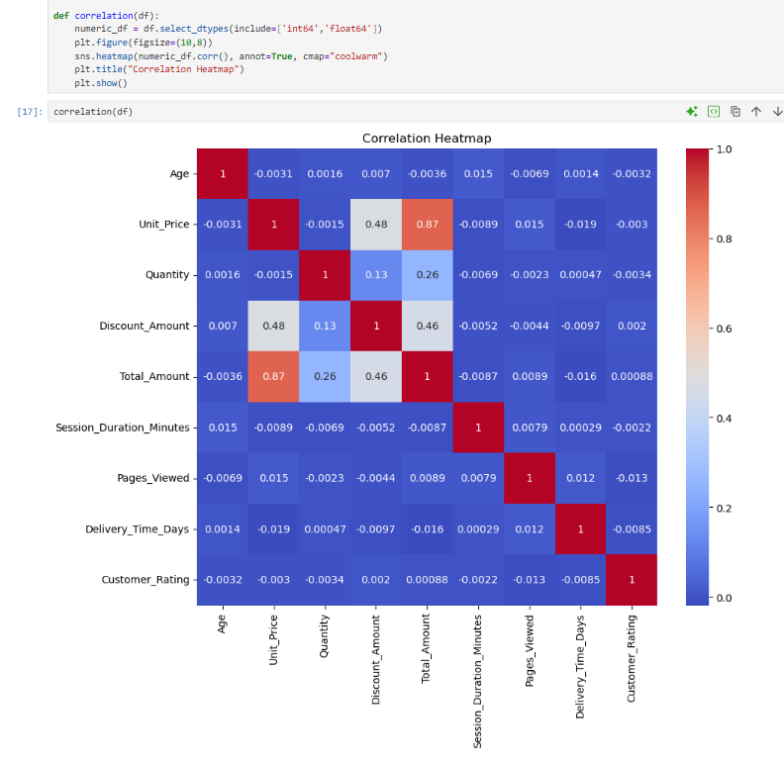

Count Graph: Returning customers vs none returning
Below I created a boxplot graph to visualise my classifier
From our results. We can see that roughly 15,000 of the customers will return while roughly 2,000 are not. This highlights a major issue in this classifier within this dataset. This is because it is highly unbalanced. This means that it will make accuracy misleading when we create our models. However this is typically seen in most dataset and will mean that when we use our training and testing data it is very important to make appropriate samples to accommodate this.

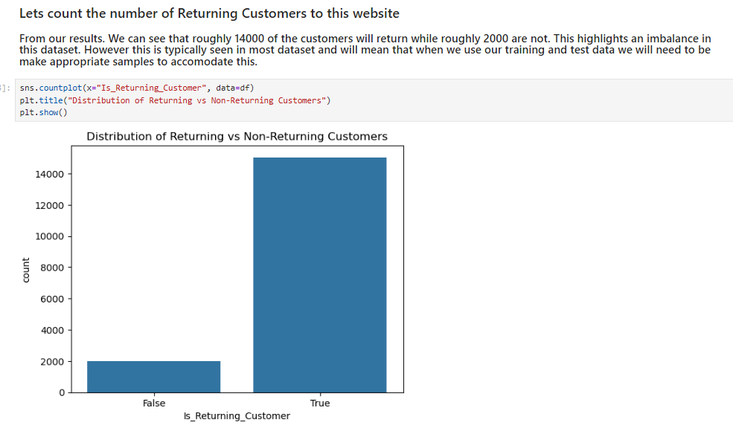

Count graph: Devices vs returning Customers
Here I created another count graph that looks at what customers that are returning/not returning and what devices they were using to access the website.
From the below graph we can analyse that most customers are viewing this website on their phones. We can also see that most non-returning customers are using their laptop. This may suggest the user interface on the tablet may need to be improved.
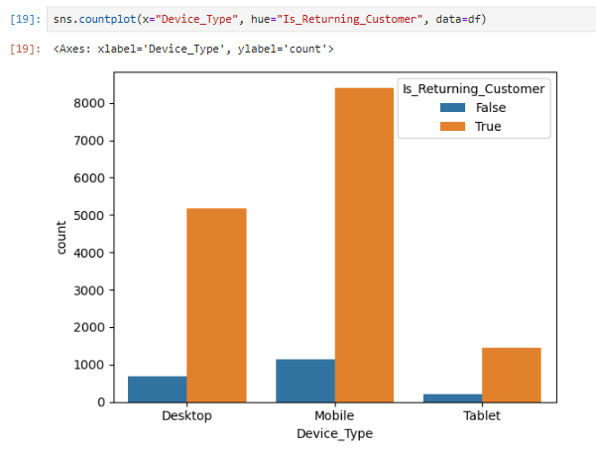

Pie chart: Gender Distribution:
Here I created a Gender Distribution chart to see what proportion of the site identifies as male, female or other.
Below we can observe that most customers are female, at 50.5%, while the males make up 48.0% and the remainder of customers go by other at 1.5% This tells us that overall gender distribution is very equal. Likely the business won’t need to appeal to one gender over another.
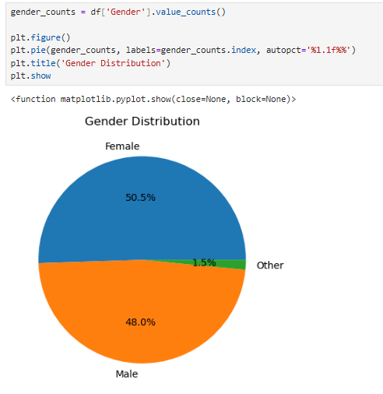

Histogram: Age Distribution:
I have created a histogram function to see what age groups interact with the business. I have set bins at 20 to condense this graph to be the optimal size.
As we can see in the Histogram below, there seems to be a large amount of young people and middle-aged users interacting with the sight however we can see that after the age of 40, the distribution begins to decrease. This tells us that the customer-base mostly consists of users aged around 16 to mid-40s
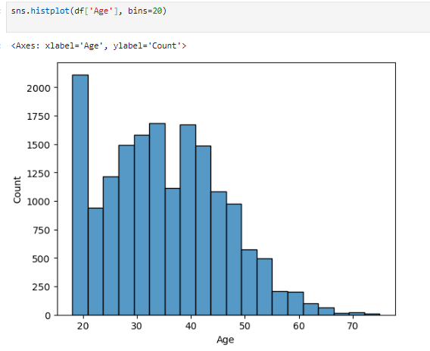

Histogram: Review Rating Distribution
Here I have created a similar graph bit now with the Customer_Rating variable:
As we previously saw that the mean for Review Ratings was 3.9 which suggests it is a mostly positive distribution. This tells us their reviews are mostly positive however there are still a chunk of negative reviews that should also be consider.
This could be something that the store should take note of going forward in order to increase higher ratings and decrease lower ones near 3.0
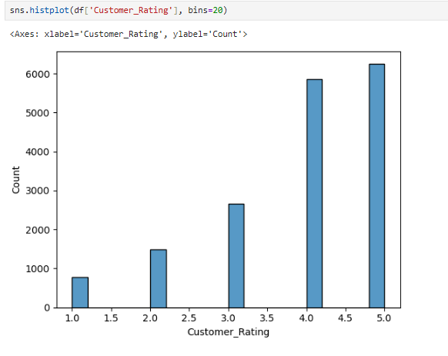

Bivariate Analysis: Returning Customer by Product Category:
I then conducted a bivariate analysis to examine if there is a relationship between Product Categories being purchased vs the Returning Customers.
We can analyse first that there isn’t a relationship between customers not returning and specific product categories as they are all roughly the same. This may indicate that customers that do not return aren’t influenced by any specific products.
On the other end. Returning customers are most likely to purchase Sports, Beauty and Book products mostly. However as we can see there isn’t a noticeable difference in customer product preferences between both groups of customers.
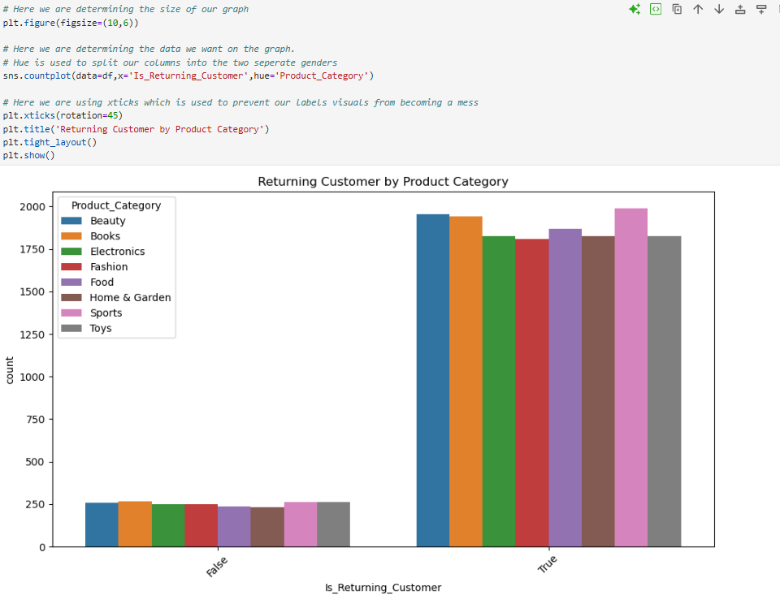

Boxplot: Returning customers vs Webpage Session Duration
For my final analysis as part of the EDA I created a Boxplot to measure the returning/non returning customers by how long they were spending on the website to identify a correlation:
Below I found that this graph clearly indicates that Customers that are returning to the website, are spending a greater amount of time on the website compared to people who are not returning to the website.
This could indicate that users who aren’t satisfied with the website's offerings or interface, won’t spend much time on it Perhaps the websites interface needs to be improved to make it more user friendly.
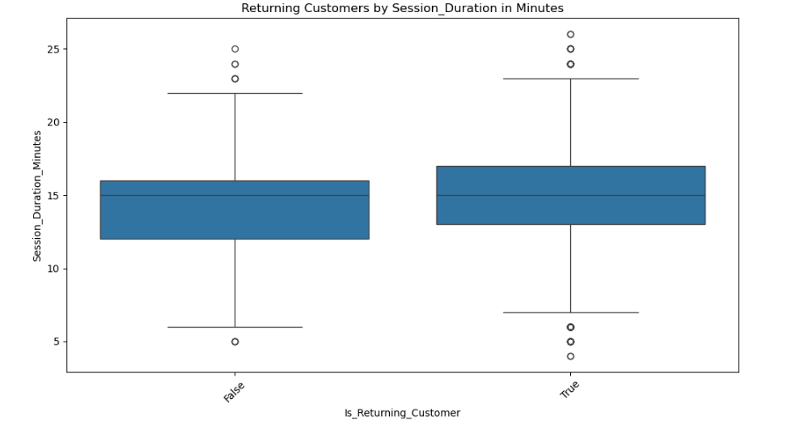

Machine Learning Model Justification and Implementation

Decision Tree and Random Forest
Now that my dataset was trained, it was time to start experimenting with different algorithms and models. First I began by utilising Random Forest which utilises multiple Decision trees during the training process, then based on the combined outputs of the decision trees, they determine using classification and regression tasks the most accurate and stable predictions. I utilised Decision Tree and Random Forest as it is a simple dataset that aims to choose the most optimal output based on previous figures and for the number of variables to consider I believed Random Forest was the best choice here.
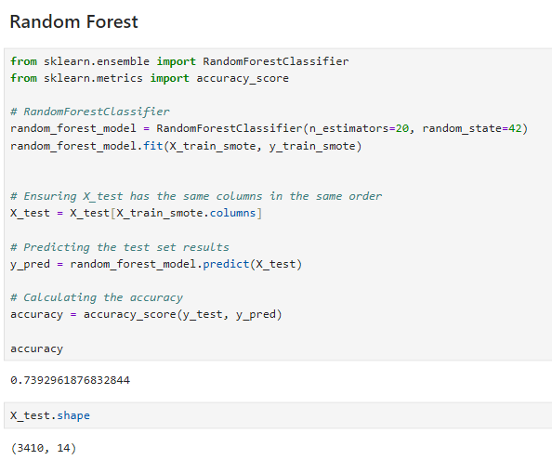
As we can see this Random Forest model it seems to be mostly accurate for this dataset. As it contains an accuracy model of 73%. However this isn’t telling us the full picture. Let’s test this on a more accurate model by utilising boosting more specifically Gradient Boosting.

Gradient Boosting
Our Random Forest model seemed very accurate, however it’s important to make sure that our model is taking random subsets of our data samples and choosing the most accurate. This is when I decided to utilising the Boosting algorithm. However I’m using the Gradient Boosting version of this because I want the model to also learn from its inaccuracies to make it more accurate by increasing and decreasing weight of the misclassified samples.
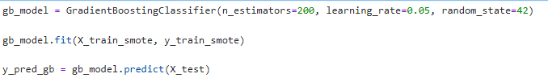
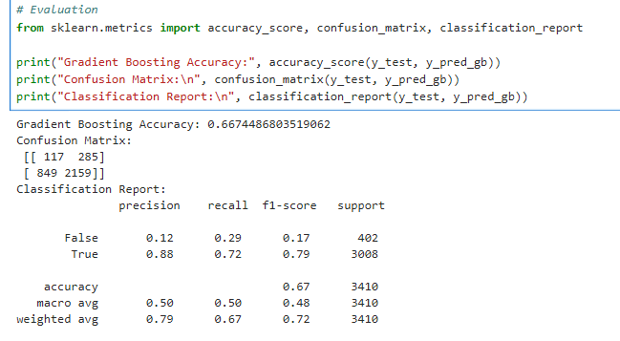
We can see here in the Confusion Matrix, it shows us that 117 times the model got a True positive someone will not return to the website however it also identified this falsely 849 times via a False Positive. However we can see that the model has 2159 True Negatives meaning its accurately predicting customers that will return to the website.
Looking at our Classification Report we are seeing False (customers not returning) has a precision score of 0.12 meaning 12% is predicted accurately whereas recall is 0.29 or 29%, so its predicting less than is being identified with an overall f1-score of 0.17 or 17%. On the other hand, True (customers that are returning) is accurately identified 0.88 or 88% of the time with a recall of 0.72 or 72% with a final f1 score of 0.79.
While this model has a 66% accuracy score, our confusion matrix clearly tells us our data model has mostly failed to predict customers that will not return to the website. This is because of the large class imbalance in the dataset with this model, despite containing n-estimators and slower learning rates, it still has a major bias towards the majority class of returning customers. This means the accuracy alone is misleading and this is also likely the same case for the Random Forest model also. With this insight I decided to try add a new technique to find more accurate parameters.

Gradient Boosting model – utilising the Grid Search Technique
Next I wanted to try and find the most optimal parameters to utilise to see if this would improve the models ability to make more accurate predictions.
To do this I implemented the Grid search technique into the model which aimed to utilise factorial design experimentation to determine the best parameters that the gradient boosting model should utilise in order to maximise its accuracy.
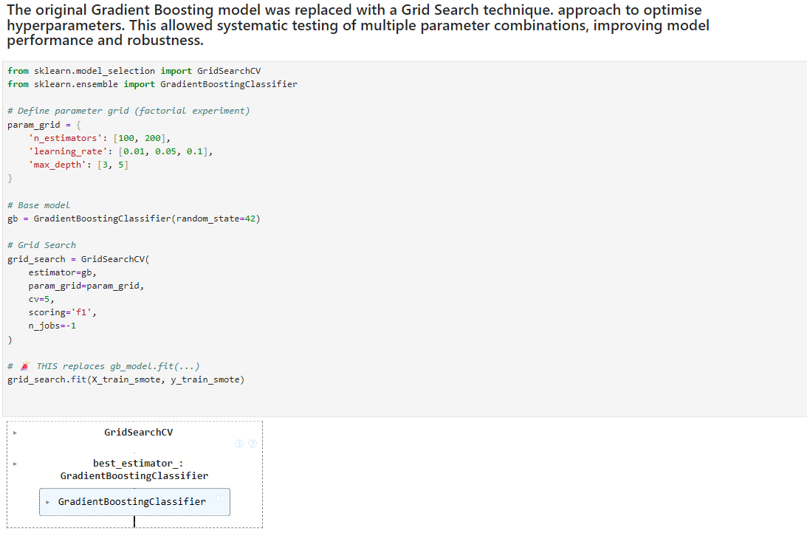
Now let’s view the best model it found:
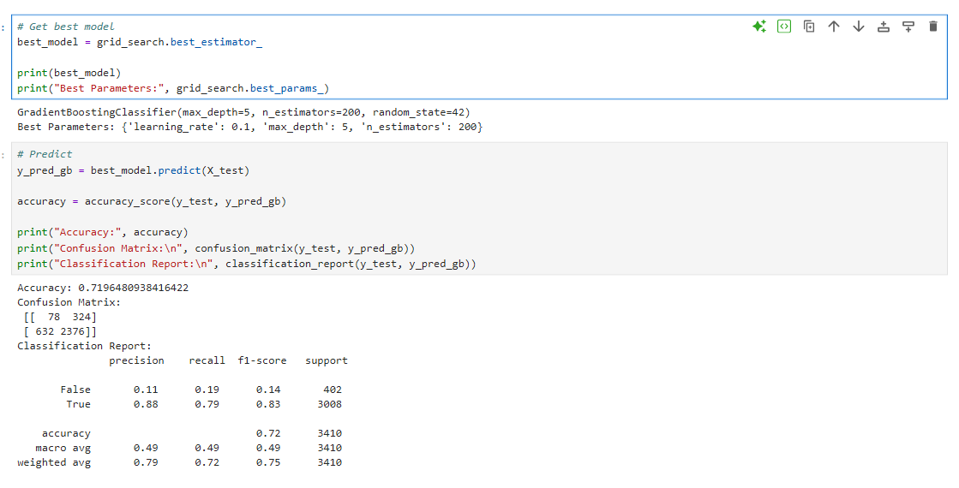
Here we can see that our accuracy score has improved from our previous gradient boosting model from 66% to now being 72% more accurate. However when we analyse the Confusion Matrix and the Classification Report we can see that our models ability to predict customers not returning has actually diminished a bit as now it’s only accurate around 14% of the time according to the F1-score. This tells us that while our parameters are optimised to provide the most accurate score, at the cost of our database suffering from imbalance in customers returning to the store data which our model will aim to predict more of in order to increase the accuracy of the mode, at the cost of actually trying to predict customers not returning to the store.

Logistical Regression
As we can see, this major imbalance is going to make finding an accurate churning prediction model difficult. While I am going to continue experimenting with trying to implement different methods of reducing imbalance, I want to shift my focus towards understanding how our variables influences on our model’s predictions and what this can tell us about customers returning or not returning to the website. A new question I aim to understand with this model will be: Which is most influential to customer behaviour, Price or User Experience?
Here I decided to utilise a Logistical Regression model as part of my analysis because it is primarily used in order to predict an event falling between one of 2 categories which my main classifier aims to do. It will also allow us to implement more methods of having our model become less biased towards the majority classifier.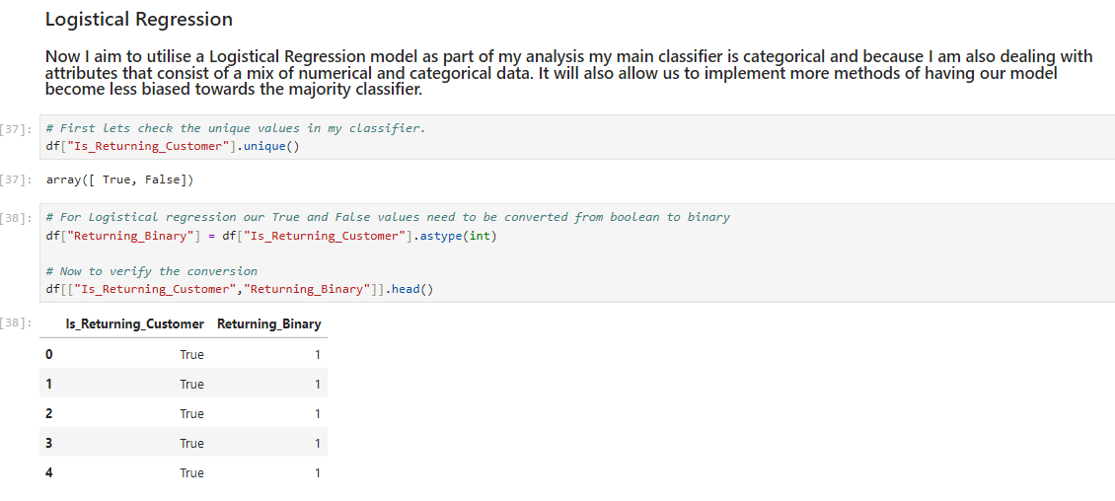
For this Logistical regression model, I wanted to reduce the variables bins to a smaller amount of specific variables to compare how these separate variables are influencing the model to attribute weight to them and therefore how much they are influencing the customer.
Here I have created 2 separate bin lists, one looking at price related data and the other looking at user experience related data. Then Ive created a total features list for later to calculate every weight value and return binary list to return my outputs in binary.
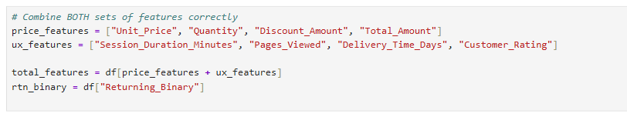
It is important to highlight that when I split this data, I needed to ensure that I utilise Stratified Sampling because our classifier is unbalanced. I also resampled using Smote to ensure Oversampling is included. I then added Scaling to the model because I needed to transform all of my features into the same scale in order to reduce another form of imbalance from taking place. In the next cell I began training my model using the Logistical Regression model and once that was trained, I look at the Accuracy score, Confusion Matrix and Classification report
Below we can derive that from training our scaled, oversampled data on our total bin count, we can derive that this model has a similar outcome to our previous models where, it’s very accurate at predicting customers that are returning and very poor at accurately identifying and predicting customers that are not returning due to the imbalance in the data without overall model being 57% accurate. However despite this we actually want to find out what features (Prices vs User Experience) are getting the most influence/weight from this model.
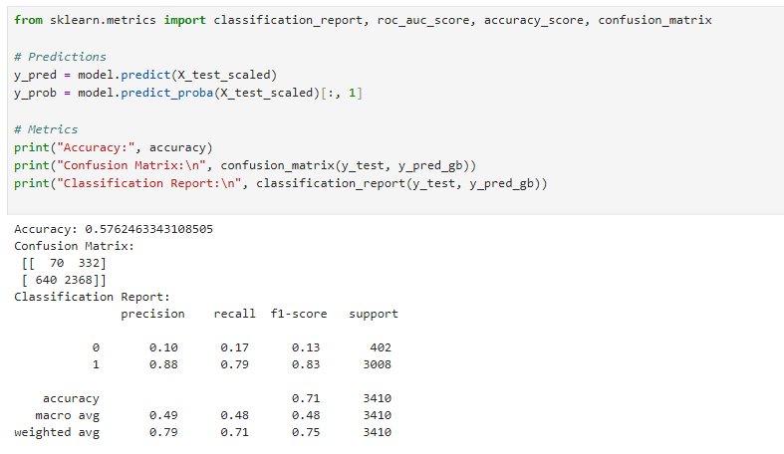

Then I defined my coefficients function which identified the weighted values associated with my variables
Below we can see that the top 3 most influential attributes are Customer Rating, Unit Price and Total Amount. An important thing to note also is that Total Amount is a negative co-efficient which suggests it’s a majorly negative influence in customers coming back. This may suggest the store needs to look into how its products are priced in order to influence more engagement.
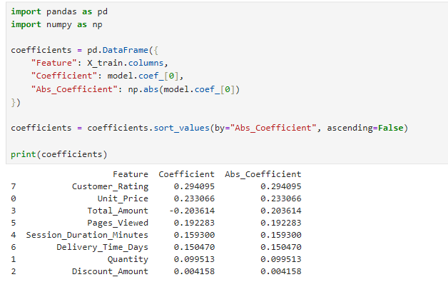

To conclude my Logistical Regression model, we can derive from the results, that the User Experience has a greater influence over the Price factors when it comes to predicting whether a customer will return to the store or not due to Price having a coefficient average of 13% and User Experience having a co-efficient average of 20%.
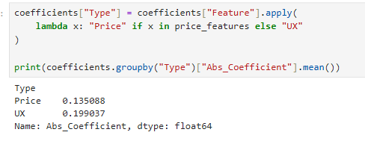

Artificial Neural Network

What I plan to do in this Artificial Neural Network (ANN) experiment is to see 2 main things, One I want to analyse how much more accurate I can make my model despite the major imbalance by utilising different types of hidden layers and activation functions. Secondly, I want to use this same architecture on my different features from my previous model. So I’m making one model to test Price, then another to test User Experience and a third utilising both sets of features.
I am utilising ANN specifically here because these models are capable of learning complex relationships and uncovering patterns that my previous more simple models couldn’t detect.
For the purposes of keeping this section concise I will go over my code for the First model and then show the results of all 3 models as my code architecture is the same throughout, just with changing the bin values.
First I decided to define new bins for my model as I tried reusing them from my Logistical Regression model but it didn’t work. Once I defined my bins with my Price related data I split it and reutilised the scaler function.
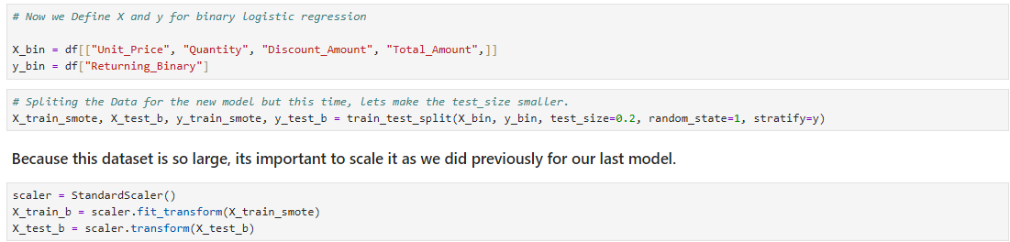
I then began building my ANN model. I first created the ANN environment in Sequential because It allowed me to be able to build my neural network layer by layer which is what I begin doing below this code.
Next I create my Input Layer along with my first hidden layer. The end of the code is where I generate my Input layer, then I’m creating a hidden later where I want my layer to by fully connected with 32 neurons, I’m choosing 32 specifically because it’s a good starting number of summarised weights and input data before the next layer which will be 16 until I get one final output.
For these hidden layers I also chose the activation function: Rectified Linear Unit (ReLU) because it will output 0 for any negative numbers and helps my network understand more complex patterns.
Then on my output layer I have chosen the activation function Sigmoid because it outputs variables between 0 and 1 which is what we need since we want to determine if a customer won’t return (0) or will return (1)
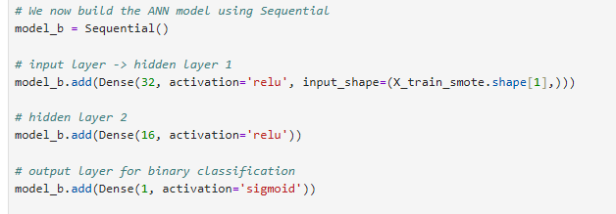
Next I need to compile my model which is where we provide our rules on how the model will learn from the data. The optimizer “adam” aims to have the model adjust and update its weights during training. The Loss function “binary cross-entropy” aims to have the model constantly adjust itself if it makes any incorrect binary related predictions to minimise Loss. I.e. reduce false positives or true negatives. The Metrics being accuracy basically allows the model to report its own accuracy metrics.
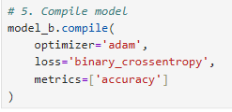
Then I needed to train my model, however I also need to set my parameters for training. An important parameter I need to include is my epochs and batch size. I have set both to 20 in order to ensure I’m not overfitting and so my model has enough reviews of my data before needing to adjust. 20% of my data will be used for validating which will aim to tell me if the models overfitting. Finally verbose is one so my can see my progress bar as it trains.
Once the models trained, I predicted on my test data. I want my model to classify that if my output is over 0.7 than there is a high likelihood that a customer will return otherwise the customer will likely not return, this code will aim to show how accurately does my model predict this going forward. The reason I am setting the threshold of 0.7 is to encourage my models to identify classifiers of customers that will not return to the store. This was the same for the rest of the models to keep architecture consistent
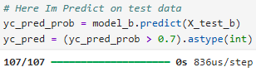

First ANN Models Results – Price Features
I then generate the accuracy score, matrix and classification report for this model. Once again I’m highlighting the large classifier imbalance present in the Confusion Matrix and Classification report. This suggests that these features alone contain very little signal for predicting the likelihood of customers returning:
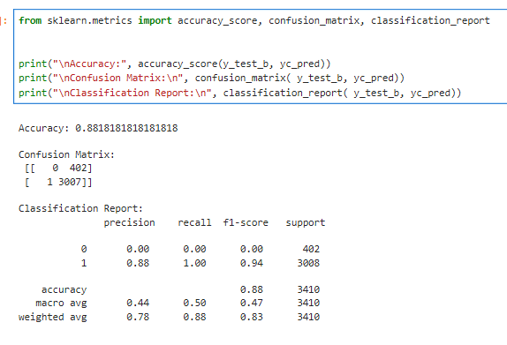
I also wanted to visualise how my model learned overtime by creating a line chart showcasing this:
This graph highlights a good learning rate from the training side and a very high learning rate from the validation loss.

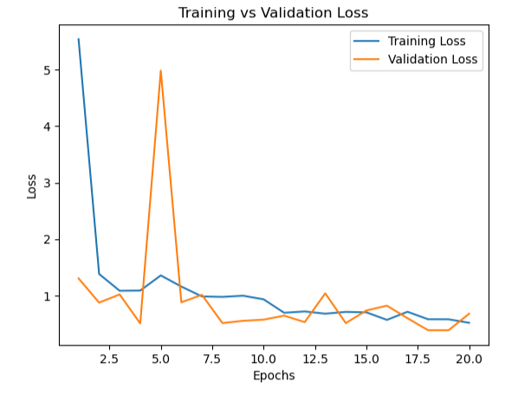

Second ANN Models Results – User Experience Features
Comparing this model to the previous one, we do see a level of improvement where it’s actually detecting both customers returning and not returning and a more balance recall overall. However at the cost of accuracy dropping to 53%. This tells us that Customer Experience contains more predictive information than the Price as we deduced from the Logistical regression model.
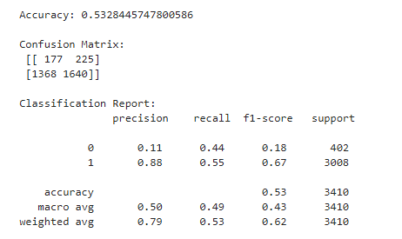
Visualised training model:
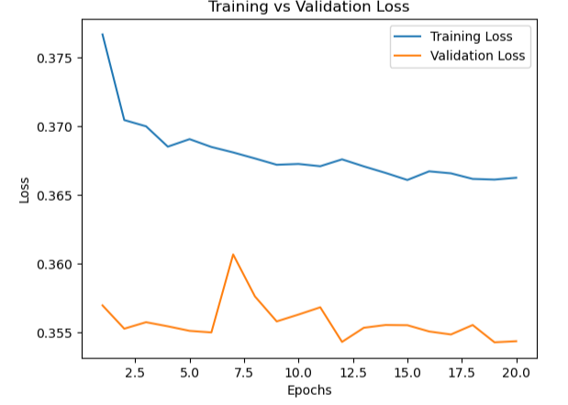

Third ANN Models Results – Price + User Experience Features
This third and final model has now provided an opposite issue where previously it was recalling the likelihood of customers returning too often due to the imbalance, now its predicting the likelihood customers will not return almost every time and is still getting the vast majority of them wrong. This tells us that combining features together heavily influences the model sensitivity and only amplifies the likelihood of imbalance.
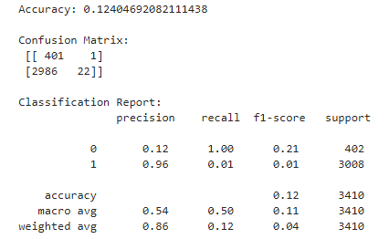
Visualised training model:
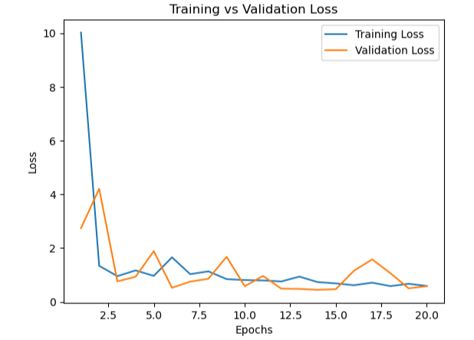

Conclusion

While the initial objective of this Analysis was to develop a Machine Learning model that would be capable of accurately predicting if a customer would return or not return to a website based off my customer behavioural dataset. Throughout the course of the analysis and building my models such as my Random Forests and Gradient Boosting models, I became more aware that I would be limited in my ability to create this accurate model due to the significant class imbalance within my dataset for my classifier. I utilised multiple methods in order to reduce this imbalance as much as possible such as Over-sampling, Grid-searching, Stratified sampling and while these methods did show a level of change, it ultimately was too much of an imbalanced dataset to be corrected.
Due to my limitation I shifted my focus towards understanding the variables, more specifically which variables had the strongest influence on customer behaviour in regards to the churn. I achieved this by utilising Logistical Regression Models to understand which co-efficient groups had the largest weights/influence when deciding the output. I also utilised Artificial Neural Networks to understand which groups had more predictive information.
The results consistently indicated that customer experience related features such a “review ratings”, “time spent on the website”, “pages viewed” and “days it takes to deliver a product” had a much higher influence on customer behaviour then price-related features. From a business data analysts perspective I would be highly recommending that the retail business should prioritise improving the overall customer experience on the website more than adjusting prices in order to boost customer retention and therefore potential future sales.
In the future I would highly recommend utilising more techniques and algorithms that target imbalance in order to derive a more accurate customer behaviour churning model.

References
UmutUygurr. (2024) “E-Commerce Customer Behaviour and Sales Analysis” Accessed on (31/03/2026), Available at https://www.kaggle.com/datasets/umuttuygurr/e-commerce-customer-behavior-and-sales-analysis-tr

